# Sentiment Analysis Report

## Video details

• Title: Hopes grow of deal to free hostages in Gaza -| BBC News  
 • Channel: BBC News  
 • Uploaded on: 2023-11-19T22:55:36Z  
 • Views: 114021  
 • Likes: 982  
 • Comments: 904  
 • Comments extracted: 521

## Sentiments Labels and scores info

**• Positive:** Score >= 0.2 **• Neutral:** 0.2 > Score > -0.2 **• Negative:** -0.2 >= Score

## Sentiments Frequency

**• Positive:** 141 **• Neutral:** 131 **• Negative:** 249

## Sentiments Frequency plot

**1. Plot on the basis of sentiment labels**

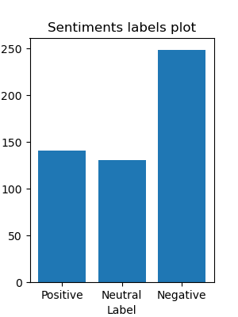

**2. Plot on the basis of sentiment scores**

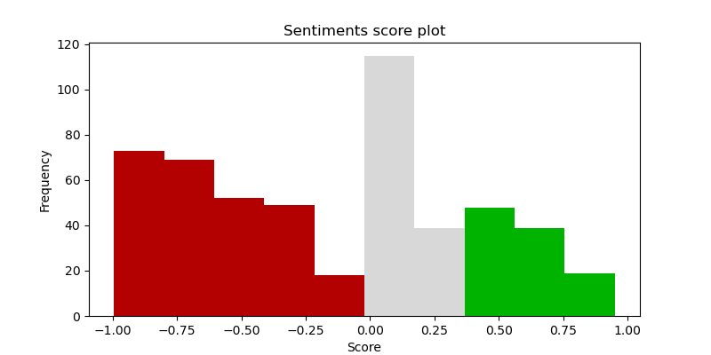

## Top comments for each sentiment, by score

**1. Positive**

|  |  |  |
| --- | --- | --- |
| Author | Comment | Sentiment Score |
| olive tree | Peace be with ❤️  The Word of the LORD ALMIGHTY: Gaza will be forsaken, Ashkelon will be desolate, Ashdod will be driven out by day, Ekron will be uprooted.  Woe to the Cherethites, inhabitants of the seashore, O Canaan, the land of the Philistines, for the word of the LORD is against you, for I will destroy you and leave you without an inhabitant.  The seashore will be a meadow, with shepherd's huts and sheepfolds there."  All these disasters are happening to fulfill the Prophecy of wrath that does not follow GOD's Word.  We humans can 'never' oppose or criticize GOD's will, but we can avoid GOD's Fierce Wrath and save our souls.  We must believe in the LORD JESUS CHRIST, the only begotten Son of GOD, who paid for the sins of the world and us humans through the cross, and follow His will!  The only way to avoid the Fierce Wrath of GOD and to not stand in Judgment is to Believe and keep the Words of the LORD JESUS CHRIST.  Psalm 2:7,12. I proclaim the commandment of the LORD. The LORD said to me, “You are my son; today I have begotten you.”  Kiss his Son, lest he be angry with you, and you perish from your way; for his wrath is kindled. Blessed are all who take refuge in the LORD."  John 1:1-3 Mark 1:15 Luke 3:8-14 John 3:5-6  May the Mercy of GOD and the Grace of the LORD JESUS CHRIST be upon all! 🙏❤️ | 0.9512 |
| Jonathan T. Modesto | (Daniel 9:27 was fulfilled on August 13 2023 also when the woman began travailing in birth to fulfill the time of the gentiles for the mystery of Revelation 12 to be completed, Daniel 12:1 next, three riders released within 2020 and 2023. These words are true and worthy and he who has ears to hear let him hear and blessed is he who understands.)    *“And as he sat upon the mount of Olives, the disciples came unto him privately, saying, Tell us, when shall these things be? and what shall be the sign of thy coming, and of the end of the world?”*  Gospel of Matthew, chapter 24, verse 3.    *“And he said, Take heed that ye be not deceived: for many shall come in my name, saying, I am Christ; and the time draweth near: go ye not therefore after them. But when ye shall hear of wars and commotions, be not terrified: for these things must first come to pass; but the end is not by and by. Then said he unto them, Nation shall rise against nation, and kingdom against kingdom: and great earthquakes shall be in divers places, and famines, and pestilences; and fearful sights and great signs shall there be from heaven.”*  Gospel of Luke, chapter 21, verse 8 to 11.    *“All these are the beginning of sorrows. Then shall they deliver you up to be afflicted, and shall kill you: and ye shall be hated of all nations for my name's sake. And then shall many be offended, and shall betray one another, and shall hate one another.”*  Gospel of Matthew, chapter 24, verse 8 to 10.    *“And there shall be signs in the sun, and in the moon, and in the stars; and upon the earth distress of nations, with perplexity; the sea and the waves roaring; men's hearts failing them for fear, and for looking after those things which are coming on the earth: for the powers of heaven shall be shaken. And then shall they see the Son of man coming in a cloud with power and great glory. And when these things begin to come to pass, then look up, and lift up your heads; for your redemption draweth nigh.”*  Gospel of Luke, chapter 21, verse 25 to 28.    *“For God so loved the world, that he gave his only begotten Son, that whosoever believeth in him should not perish, but have everlasting life. For God sent not his Son into the world to condemn the world; but that the world through him might be saved. He that believeth on him is not condemned: but he that believeth not is condemned already, because he hath not believed in the name of the only begotten Son of God.”*  Gospel of John, chapter 3, verse 16 to 18.    *“For I delivered unto you first of all that which I also received, how that Christ died for our sins according to the scriptures; And that he was buried, and that he rose again the third day according to the scriptures: And that he was seen of Cephas, then of the twelve: After that, he was seen of above five hundred brethren at once; of whom the greater part remain unto this present, but some are fallen asleep.”*  First Corinthians, chapter 15, verse 3 to 6.    *“Repent therefore of this thy wickedness, and pray God, if perhaps the thought of thine heart may be forgiven thee.”*  Acts, chapter 8, verse 22.    *“Jesus answered and said unto him, Verily, verily, I say unto thee, Except a man be born again, he cannot see the kingdom of God.”*  Gospel of John, chapter 3, verse 3.    *“From that time Jesus began to preach, and to say, Repent: for the kingdom of heaven is at hand.”*  Gospel of Matthew, chapter 4, verse 17.    *“After two days will he revive us: in the third day he will raise us up, and we shall live in his sight.”*  Hosea, chapter 6, verse 2.    *“But, beloved, be not ignorant of this one thing, that one day is with the Lord as a thousand years, and a thousand years as one day.”*  Second Peter, chapter 3, verse 8.    *“knowing this first, that there shall come in the last days scoffers, walking after their own lusts, and saying, Where is the promise of his coming? for since the fathers fell asleep, all things continue as they were from the beginning of the creation.”*  Second Peter, chapter 3, verse 3 to 4.    *“For when they shall say, Peace and safety; then sudden destruction cometh upon them, as travail upon a woman with child; and they shall not escape.”*  First Thessalonians chapter 5, verse 3.    *“For the Lord himself shall descend from heaven with a shout, with the voice of the archangel, and with the trump of God: and the dead in Christ shall rise first: then we which are alive and remain shall be caught up together with them in the clouds, to meet the Lord in the air: and so shall we ever be with the Lord.”*  First Thessalonians, chapter 4, verse 16 to 17.    *“in a moment, in the twinkling of an eye, at the last trump: for the trumpet shall sound, and the dead shall be raised incorruptible, and we shall be changed.”*  First Corinthians, chapter 15, verse 52.    *“I tell you, in that night there shall be two men in one bed; the one shall be taken, and the other shall be left. Two women shall be grinding together; the one shall be taken, and the other left. Two men shall be in the field; the one shall be taken, and the other left.”*  Gospel of Luke, chapter 17, verse 34 to 36.  ........................................................................................................... | 0.9253 |
| The Fastfood Show | Strongly hope that both parties negotiate for peace of civilian people and especially the children and babies who know nothing why the war happen. | 0.9238 |
| Let it Be, Summer | Sending strength to the ladies to carry on Vivian Silver’s hopes for peace in the future. Peace ☮️ | 0.9186 |
| Ria Videna | Blessed is the nation whose God is the Lord. Righteousness exalts a nation. Don't cover Hamas. No good they are giving u. Gazans | 0.904 |

**2. Neutral**

|  |  |  |
| --- | --- | --- |
| Author | Comment | Sentiment Score |
| Darmith Marak | Don't blame Israel for this, it is becouse of Hamas terrorists who loves to support terrorists | -0.1935 |
| James | So the BBC can’t “verify” the clear proof and video that israel has put out but the BBC can put out hamas propaganda without including “the BBC cannot independently verify the video” being put out by hamas videos? | -0.1779 |
| Nicola Hallsworth | It's not a case of what the Israelis claim are hostages taken inside shifa hospital, the hospital cameras actually showing hostages in the hospital are a fact, and not Israel actor's playing the part , i am surprised the bbc did not claim that the tunnel was an old out of service coall mine shaft that is sealed off , defund the bbc for its propaganda | -0.1759 |
| canan | If people stick with AMK33X we wouldn't be so bored with life every day, that's not a spam you'll know what I mean if you take the few mins | -0.1609 |
| Ck | Those people should protest to Hamas and not in other countries, no wonder people say to send them back to Gaza . Clearly the Gaza people are just human shield. | -0.128 |

**3. Negative**

|  |  |  |
| --- | --- | --- |
| Author | Comment | Sentiment Score |
| 주명화 | My emotions for those victims have become dull and insensitive since I have seen too many sad death after war breaking out. But still I feel emphasize on the father whose two sons died and were embraced by their father once and for all before buried.   Israel shows us tunnels and video records of Israeli hostages dragged by Hamas at the very hospital. Now I wonder what the headman of the hospital would have said to deny Hamas's activities at that hospital after he officially denied any relationship with Hamas at his hospital when the pressure of Israeli raid went high to summon criticism from all Islamic countries?   After all, all kinds of death for both sides were stemmed from Hamas's barbarian manslaughter. And that's the results, the mourning father, the crying sister, the worrying families, and countless ppl in starvation, newly born babies whose life in danger. Whoelse should we blame, but hamas? | -0.9949 |
| Jousung Kim | [Why Koreans?-Part 2] Why are Koreans so rude? Not long ago, a beautiful teacher committed suicide due to interference and insults from parents, and there was an uproar over an incident where the chief of staff of the county governor treated someone else's precious child like a slave. It's hard to believe that something like this happened in a school where character was supposed to be taught and in the military where construction work was supposed to be clear. However, in reality, there are so many examples like this that it seems strange to even mention them. Now, the words ‘insults, disregard, and discrimination’ have become part of the daily lives of Koreans. Koreans ignore me because they are poorer than me, ignore me because the apartment size is small, ignore me because the neighborhood I live in is ugly, ignore me because my bag strap is short, ignore me because I am a slob, ignore me because my job is menial, ignore me because I am late in getting work done. , ignore people because they are short, ignore them because they are ugly, ignore them because they are disabled, ignore them because their skin color is dark, and ignore instructors because they are full-time employees. Such insults and disregard are now frequent in school settings, putting teachers under extreme stress. When you look at it that way, Koreans try to ignore people who are even slightly inferior to them. | -0.9939 |
| Ben Robinsonshhh | Hostage lol Ur government Ur UK terrorist government hacks and threatens family's I been getting same shit rail moat was on about someone stole my fiancee and been mocking me since stopping money calling me tramp through YouTube feed putting drag race to call me tranny u act like u give a shit these country's go on about this like they care some posh reporter acting like she don't demean homeless or poor bullshit u all dillysional then they use someone losing kid so they sell story they been using my persona to they thiefs links cod black ops nuketown logo as turn left out pantry pirates channel blaze pirates many other games pattern as for abuse u can go back tomos and thing they laughing at that because they watch and take piss out poor don't believe them they use kids to get a story out how many this government killing through mental abuse gov trying to kil me and have proof what they doing to me | -0.9862 |
| the 3 gaming Nerds | The shit breaks my heart bro. And im pro Israel. But i believe wars should be fought by men. And when children die its not right. I truly think that wars should also be fought with swords and sheilds like times of old. Not bombs they do to much damage to humans and earth. | -0.9826 |
| Elusa Saint Pierre | BBC news is very bias by only reporting the side of Palestinians dead and suffering while Israel people are still mourning their dead relatives and love ones during the cross border attacked of Hamas into Israel territory. These sufferings and deaths among the Palestinian people are to be blamed to the terrorist Hamas organisation whom their leaders enriched themselves while the whole Palestinian people in Gaza are starving and living miserably. | -0.9814 |

## Comments posted over dates

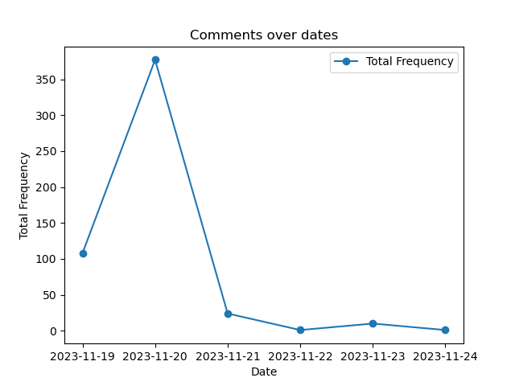

## Sentiments and date distribution

|  |  |  |
| --- | --- | --- |
| Date | Sentiment Label | Frequency |
| 2023-11-19 | Negative | 31 |
| 2023-11-19 | Neutral | 32 |
| 2023-11-19 | Positive | 45 |
| 2023-11-20 | Negative | 200 |
| 2023-11-20 | Neutral | 90 |
| 2023-11-20 | Positive | 87 |
| 2023-11-21 | Negative | 13 |
| 2023-11-21 | Neutral | 4 |
| 2023-11-21 | Positive | 7 |
| 2023-11-22 | Negative | 1 |
| 2023-11-23 | Negative | 3 |
| 2023-11-23 | Neutral | 5 |
| 2023-11-23 | Positive | 2 |
| 2023-11-24 | Negative | 1 |

## Comments posted over dates, sentiment wise

**1. Positive**

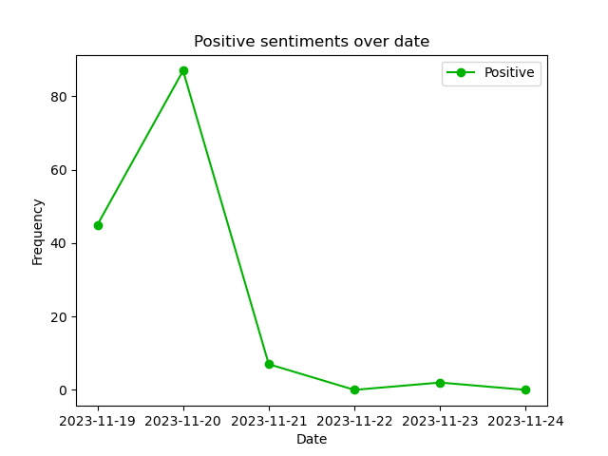

**2. Neutral**

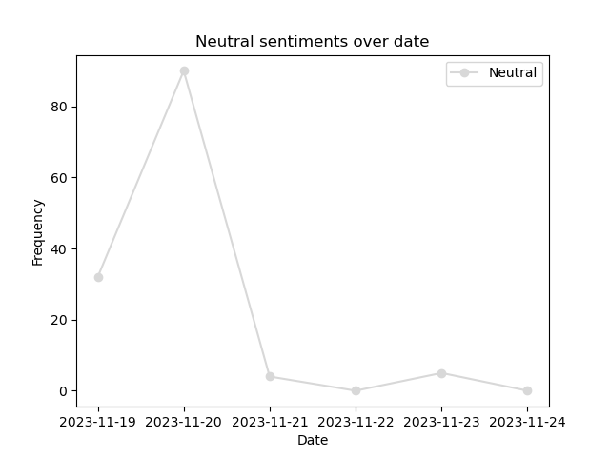

**3. Negative**

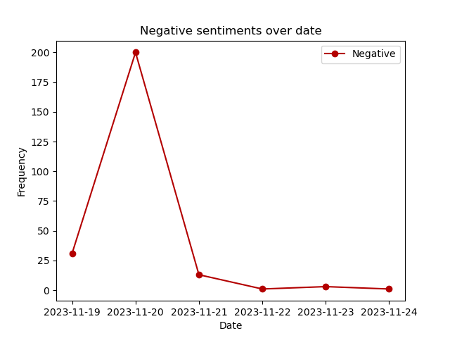

## Comments posted over dates, sentiment wise, combined

